**Implement view in hive by following the steps in the below blog:-**

Input file 1

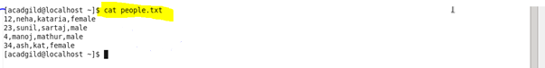

Input file 2

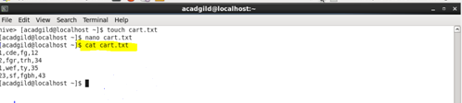

Create table and load data

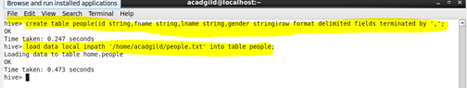

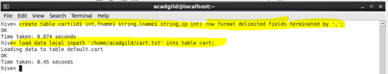

Create view

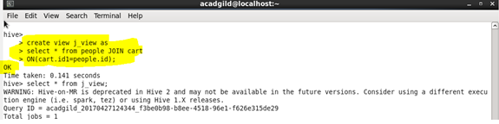

**Output :-**

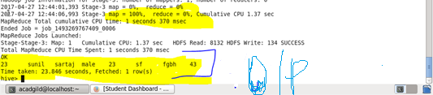

Query :-

